All About Frogs:
Frogs are my favorite animal (as you should know)…
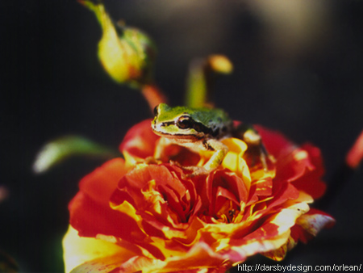

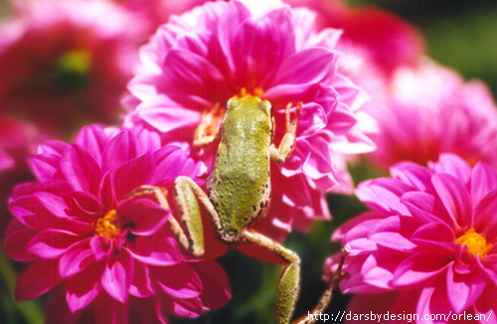
these are some really cute pix of frogs…[they are soOoOoO adorable!!!
(at least that’s what I think!)

